Java XML and JSON

1. Extensible markup language
2. XML contains both data and meta data
3. Allows to create custom markup
4. XMLs are mostly used in Data exchange, in config files and to save data, manipulate and display to the user
5. XML Processor: Any library that validates the xml
6. XML Parser: libray that reads a XML and represents a xml that is machine readable
7. XML Declaration  
     
   Encoding is the character set in the xml  
     
   Standalone by default is set to “NO”, when set to “Yes”  
   Standalone attribute tells us the xml processor that external documents are required for parsing
8. XML Attributes  
    are name value pairs
9. XML Comments:  
   
10. Character Entities: Pre definied XML entities  
    < ->&lt  
    > -> &gt  
    & -> &amp  
    ‘ -> &quot  
    “ -> &apos



1. CDATA Block  
   
2. XML supports Unicode -> UTF-8, /ASCII encoding
3. XML Schema Definition  
   Schema file is also a XML file, but with .xsd definition defines a blueprint for a xml document
4. XML Schema types:  
   Inbuilt types -> defined by W3C  
   Simple types  
   complex types
5. Simple Type  
   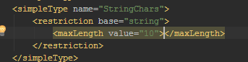
6. Enumeration  
   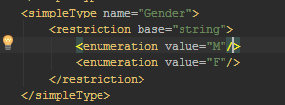
7. Complex Types  
   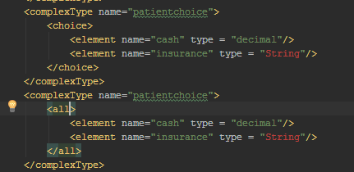
8. In the absence of xml declaration or xml declaration encoding, xml parser usually looks for the Byte Order Marker( BOM)(Which is a set of special character sequence) at the start of the document usually appended by the document editor for determining document encoding
9. XML Parsers  
   DOM -> tree based  
   SAX -> event based  
   StAX -> pull based
10. JAXP -> JAVA API for XML parsing
11. DOM Parser:Document Object Model, loads entire xml into memory and gives heirarchial access of the XML  
    Iterate through child elements  
    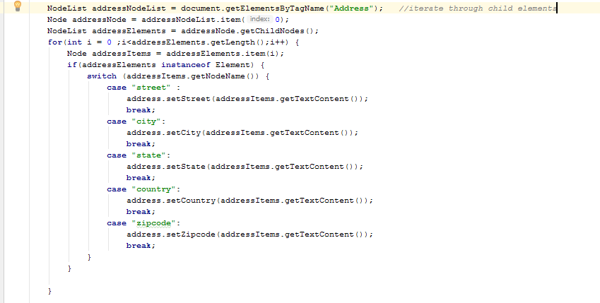  
    Gets the root element  
      
    Get the element in any path  
    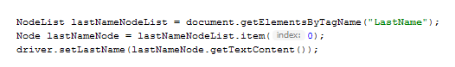
12. SAX Parser (Simple API for XML parsing) is an event based XMl parser which is more memory efficient than DOM parser as it does nt require the entire document to be present in the memory  
    SAX is read only parser, it will call the listener object for the following events  
    startDocument  
    EndDocument  
    startElement  
    endElement  
    comment  
    processingInstructions  
    characters  
      
    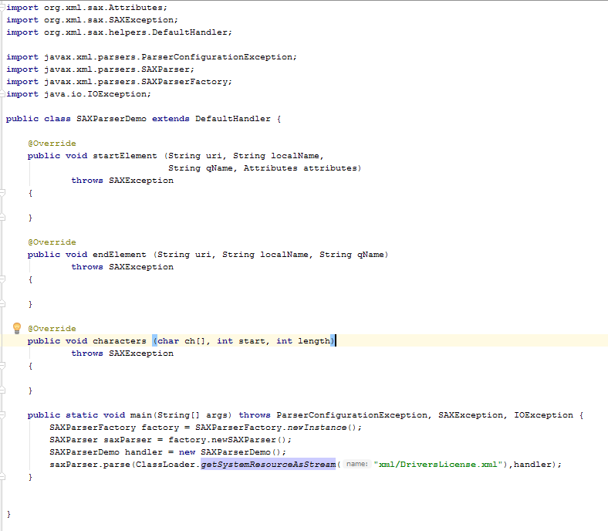  
    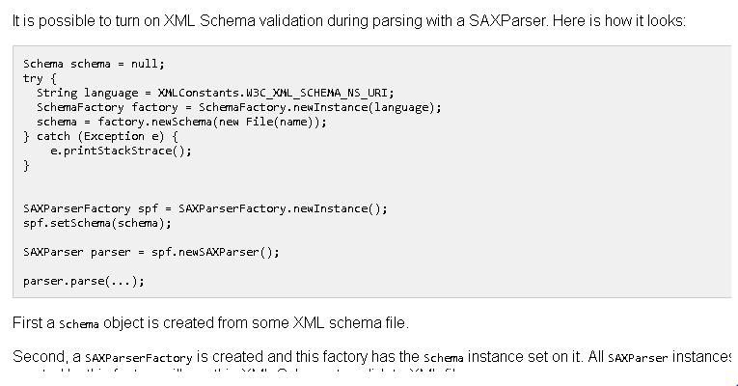
13. StAX Parser -> Streaming API for XML parsing  
    Pros -> pull based  
    Cons -> schema validation is not present  
      
    Frequently used interfaced in STAX parsers are:  
    XMLStreamReader  
    XMLStreamConstants  
    next  
    getAttributeValue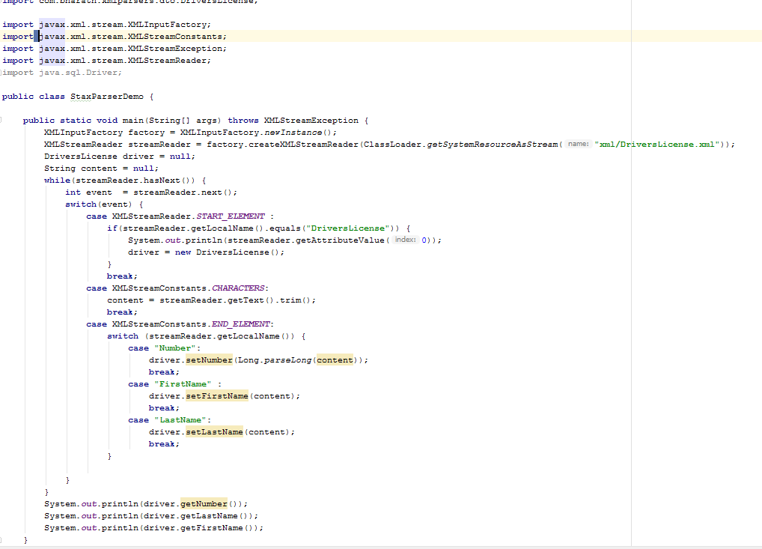
14. XSLT -> converts XML to HTML

JSON  
1) Java Script Object Notation -> JSON allows Unicode U+2028 encoding for line separator and U+ 2029 for paragraph separator

2) JSON sample file  
{  
property1 : “value”,  
property2 : value,  
property3: true,  
property4 : [  
a: b  
c: d ]  
property 5: null  
property 6 : {  
subprop: value  
}  
}  
It supports 6 types  
1) Numeric  
2) String  
3) Object  
4) null  
5) Arrays  
6) Boolean  
  
Object and arrays can be nested